**Ideation Phase**

**Brainstorm & Idea Prioritization Template**

| Date | 29 August 2025 |
| --- | --- |
| Team ID | LTVIP2025TMID61019 |
| Project Name | Order On The Go **:** Your On-Dem and Food Ordering Solution |
| Maximum Marks | 4 Marks |

**🧠 – Ideation phase**

# **Step 1: Define the Goal**

Objective: How might we create a seamless mobile-first ordering experience that saves time, reduces friction, and improves customer convenience on the go?

**Step-1: Team Gathering, Collaboration and Select the Problem Statement**

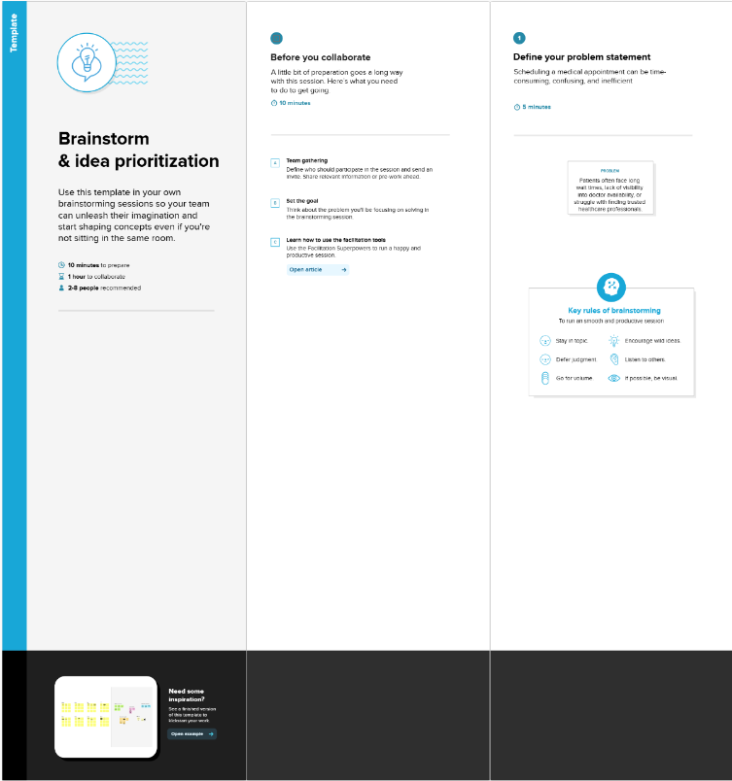

**Step-2: Prepare for Brainstorm**

Participants: Product team, developers, designers, marketing, and potential users.

Duration: 30–60 minutes.

Tools: Whiteboard, sticky notes, or digital tools (Miro, FigJam, MURAL).

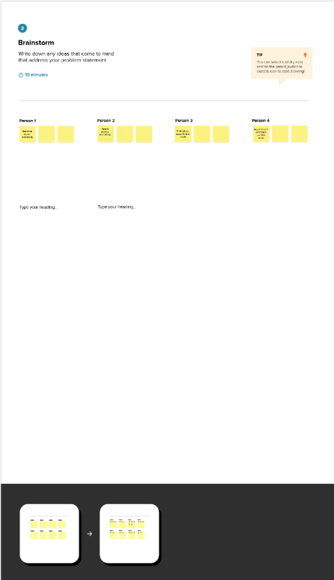

# **Step 3: Brainstorming Session**

| **Idea ID** | **Idea Description** | **Customer Pain Solved** | **Feasibility (Low/Med/High)** | **Initial Impact (Low/Med/High)** | **Notes** |
| --- | --- | --- | --- | --- | --- |
| 1 | Voice-enabled ordering | Hands-free ordering while driving | Medium | High | Requires speech-to-text AI |
| 2 | One-tap reorder | Faster repeat purchases | High | High | Best for loyal users |
| 3 | Location-based suggestions | Suggest nearest vendors | High | Medium | Needs GPS integration |

# **Step 4: Group and Refine Ideas**

Cluster similar ideas under key themes such as:

- Convenience Features (e.g., One-tap reorder, Voice ordering)

- Personalization (e.g., AI recommendations, location-based suggestions)

- Engagement & Retention (e.g., Rewards, loyalty system)

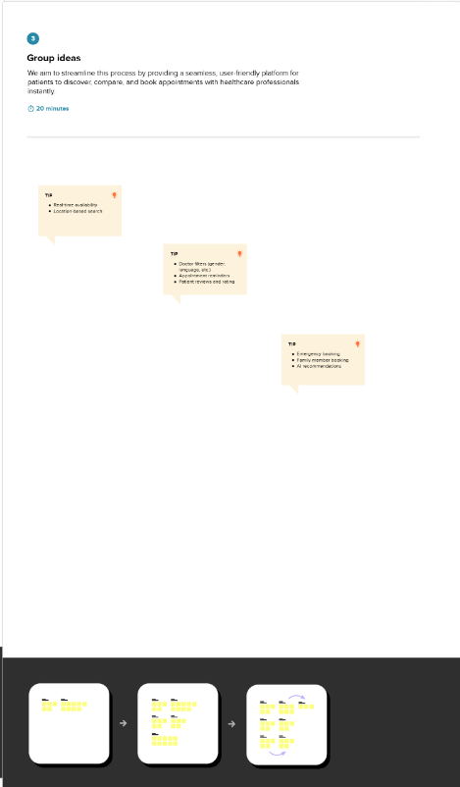

**Step-3: Idea Prioritization**

**Prioritization Matrix (Graphical Tool)**

Map ideas based on **Impact vs Effort**.

**Quadrants:**

* **Quick Wins (High Impact, Low Effort)** – Prioritize these first.
* **Major Projects (High Impact, High Effort)** – Plan strategically.
* **Fill-ins (Low Impact, Low Effort)** – Do if resources allow.
* **Thankless Tasks (Low Impact, High Effort)** – Avoid.

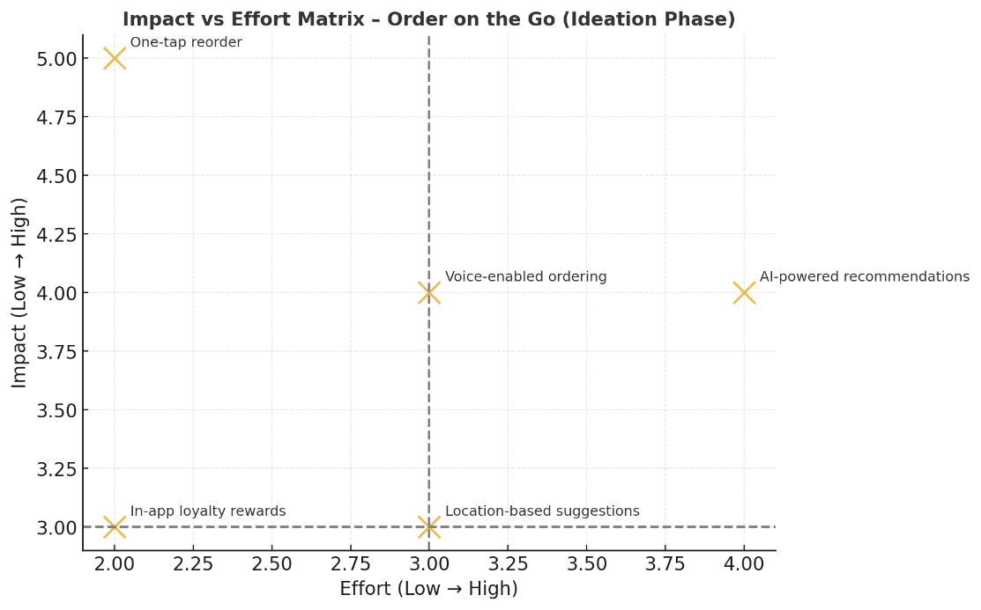

Here’s a **visual Impact vs Effort Matrix** with sample “Order on the Go” ideas plotted.

* **Top-right (High Impact, High Effort)** → Long-term strategic projects (e.g., AI-powered recommendations).
* **Top-left (High Impact, Low Effort)** → Quick wins to prioritize (e.g., One-tap reorder).
* **Bottom quadrants** → Lower priority unless resources allow.

